Indoor Positioning System

**(IPS)**

Jana Marie Gardon

Johanna Marisse Heramia

Jose Lorenzo Tadeo

MI141

# Indoor Positioning System is an enhanced GPS system that is used to locate a person's exact location and object inside the structure.

# General Objectives

* To provide user an efficient way of tracking inside the structure.
* To provide an improvement in security by locating a person inside a structure.

# Specific Objectives

* To track children
* To provide improvements on ease of tracking location whenever a person is lost.
* Provides more specific information about the location.

# Target Audience

* Consumers that are interested for personal and family use.

# Cite related architecture

* Maps.me
* Waze
* Google Map
* Uber
* Earth view - 3D map

# 

# Glossary

* **Establishment** - a business organization, public institution, or household.
* **Geographic** - Geography is the study of places and the relationships between people and their environments. Geographers explore both the physical properties of Earth's surface and the human societies spread across it.
* **GPS** - (Global Positioning System) is a satellite-based navigation system made up of a network of 24 satellites placed into orbit by the U.S. Department of Defense. GPS was originally intended for military applications, but in the 1980s, the government made the system available for civilian use.
* **IPS** - (Indoor Positioning System) is a system to locate objects or people inside a building using radio waves, magnetic fields, acoustic signals, or other sensory information collected by mobile devices.
* **Margin of Error**- an amount (usually small) that is allowed for in case of miscalculation or change of circumstances.
* **System**- a set of connected things or parts forming a complex whole, in particular.
* **API**(Application Program Interface) - is a set of routines, protocols, and tools for building software applications. The API specifies <how software components should interact and APIs are used when   
  programming graphical user interface (GUI) components.

## (Existing)

### Event Table

### Use Case Diagram

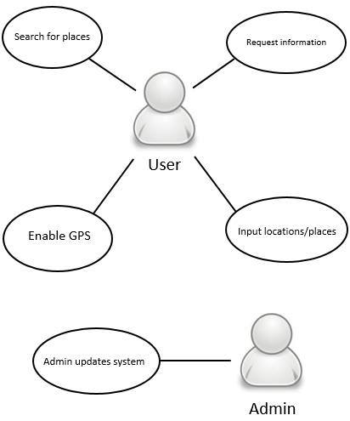

Use Case Full Description

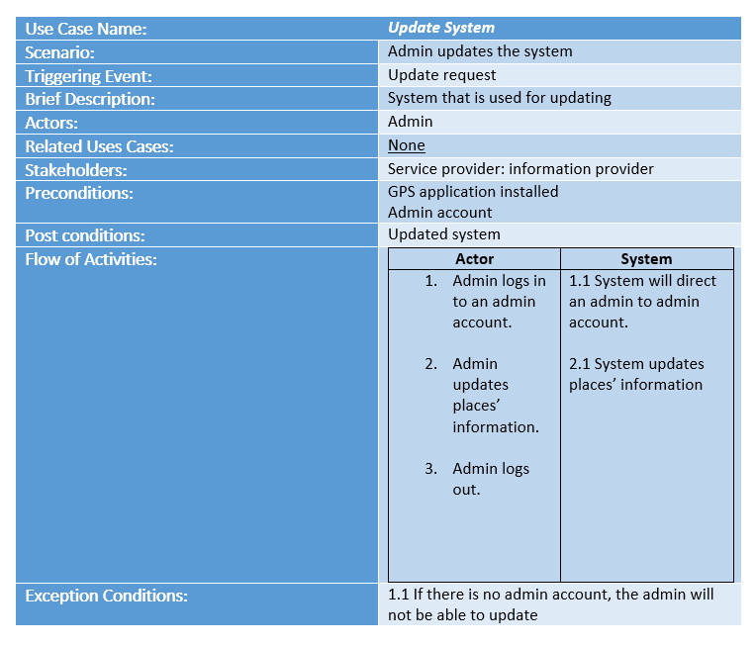

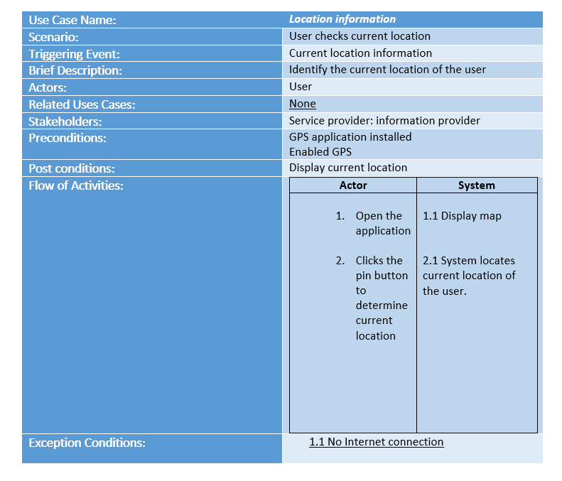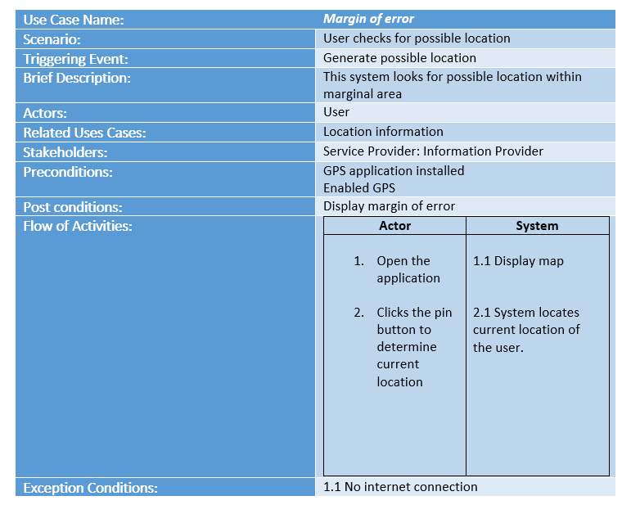

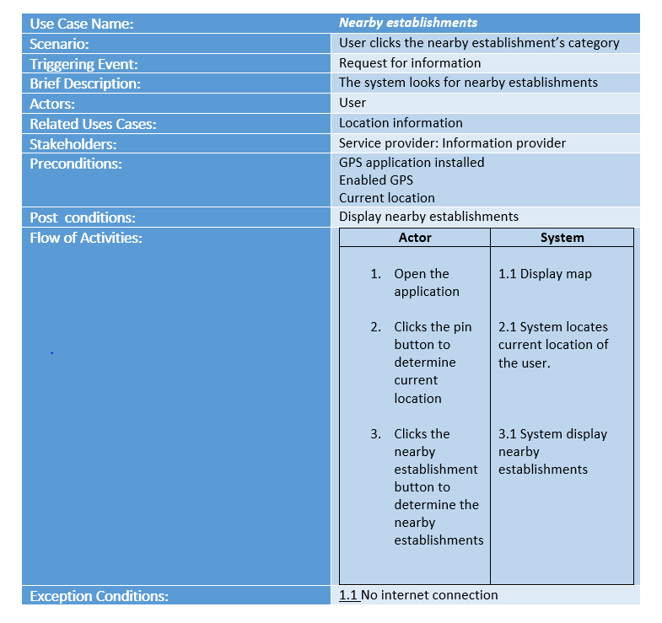

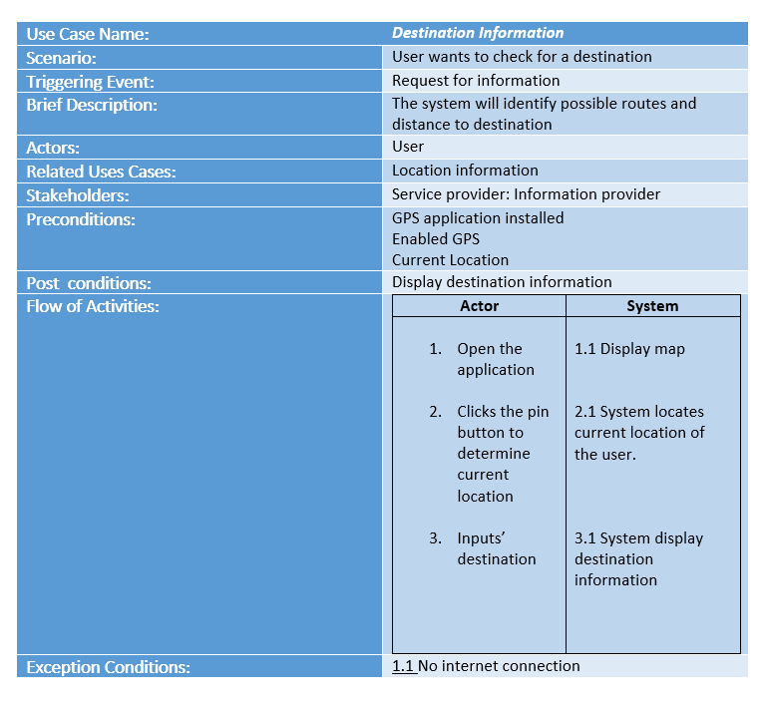

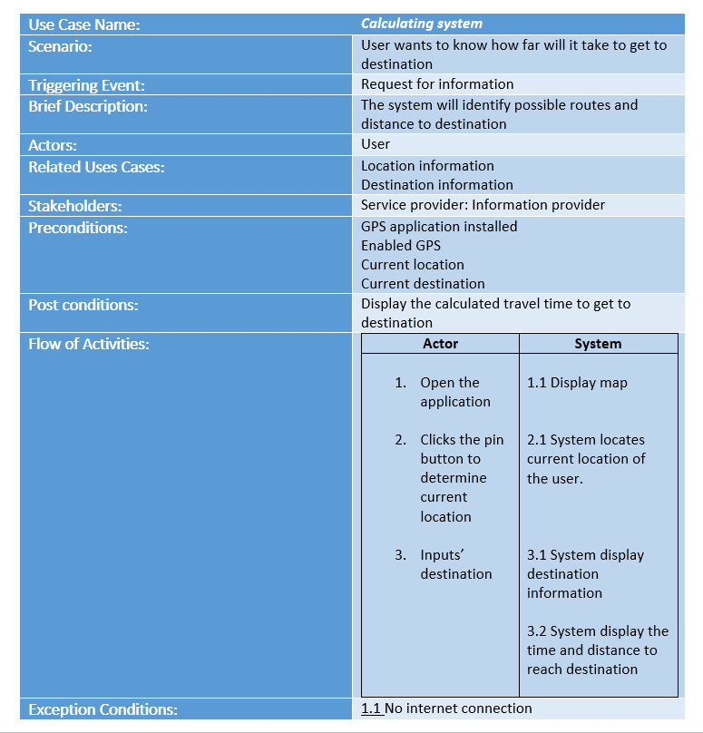

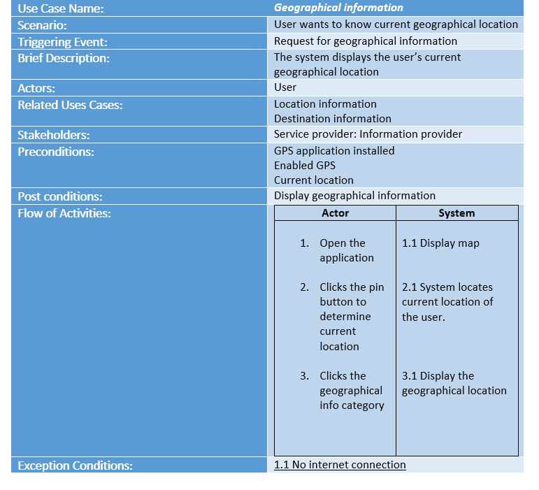

### Context Diagram

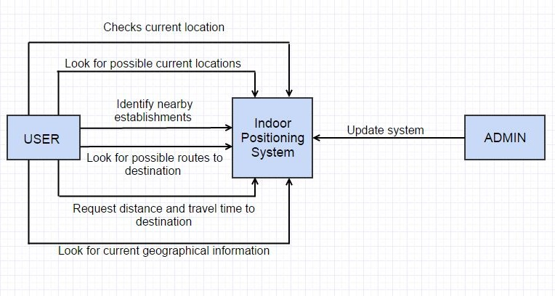

### Data Flow Diagrams

#### LVL 0

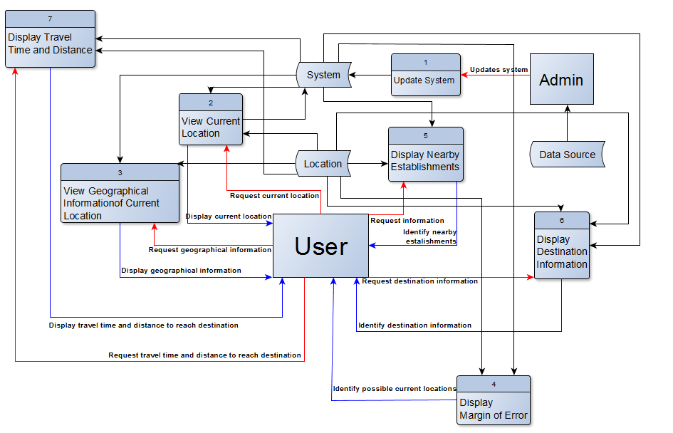

#### LVL 1

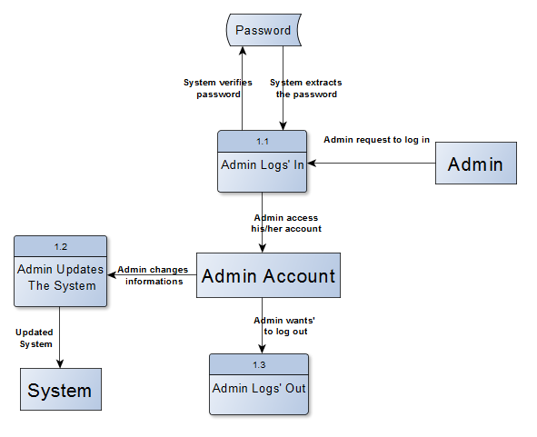

### Entity Relationship Diagrams

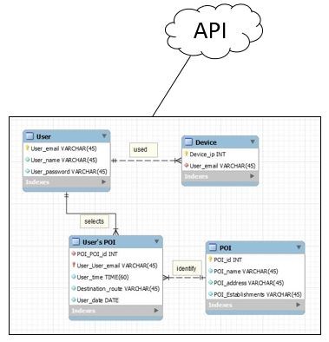

### 

### Activity Diagram

### Admin

### 

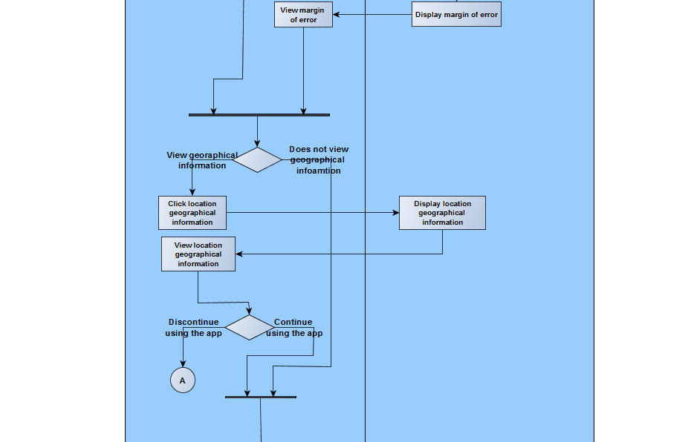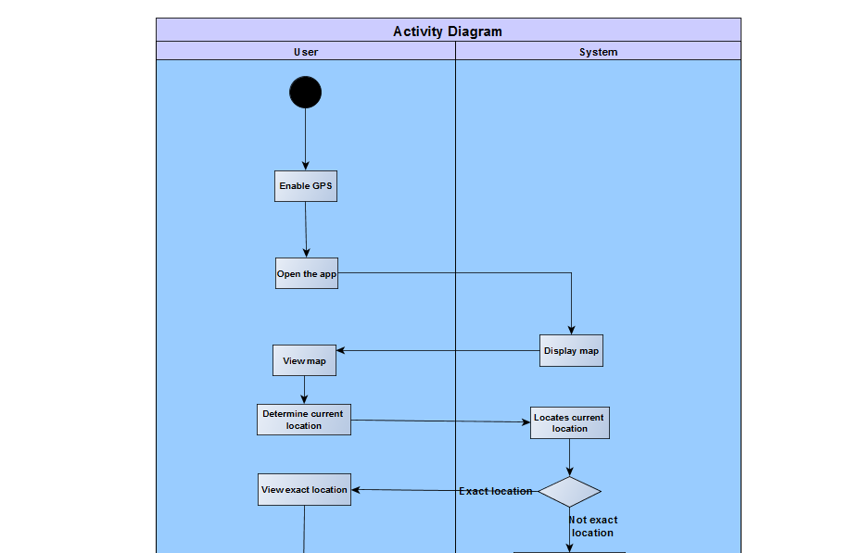

**User**

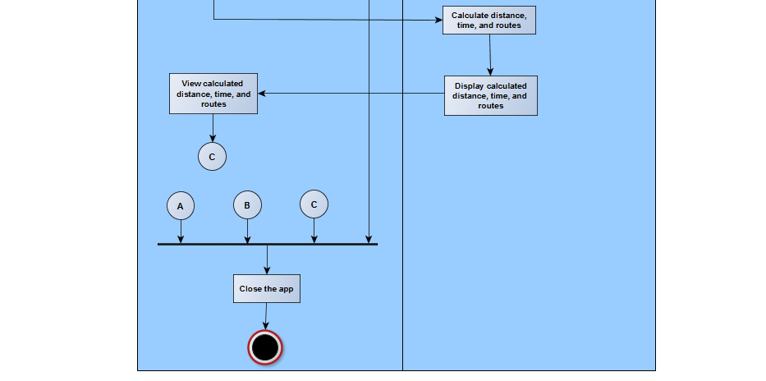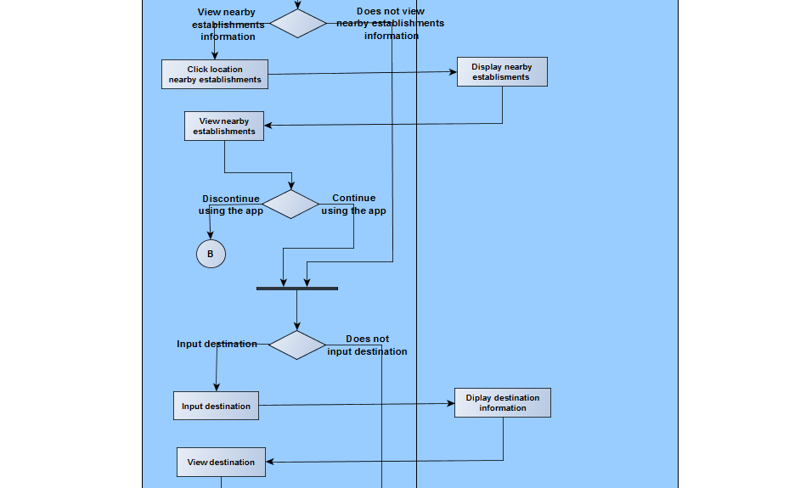

### Data Dictionary

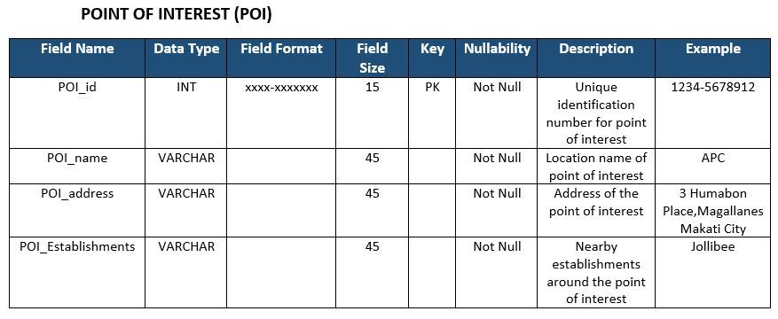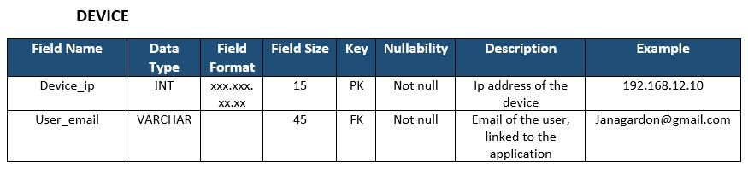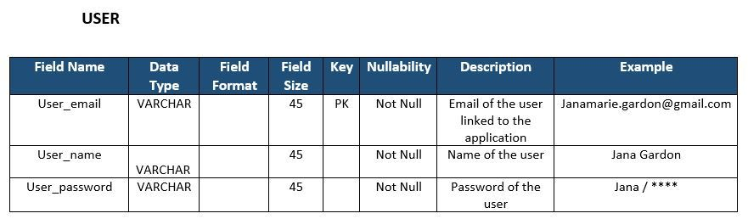

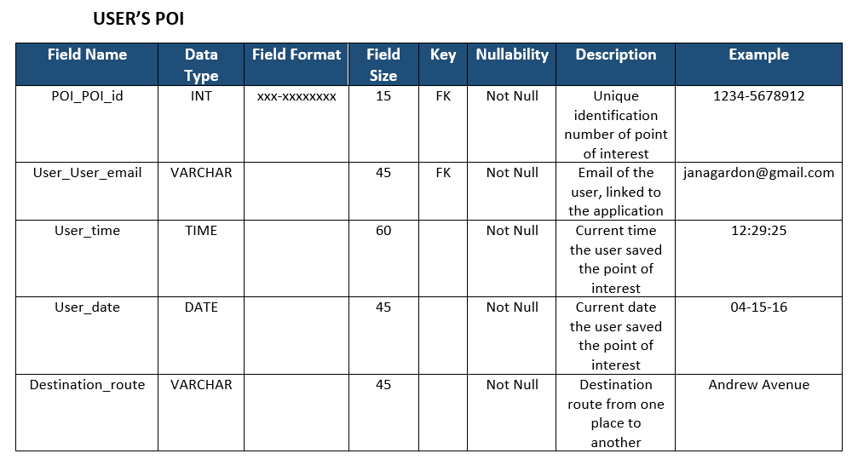

### 

### Gantt Chart/WBS/Activity List

Gantt Chart

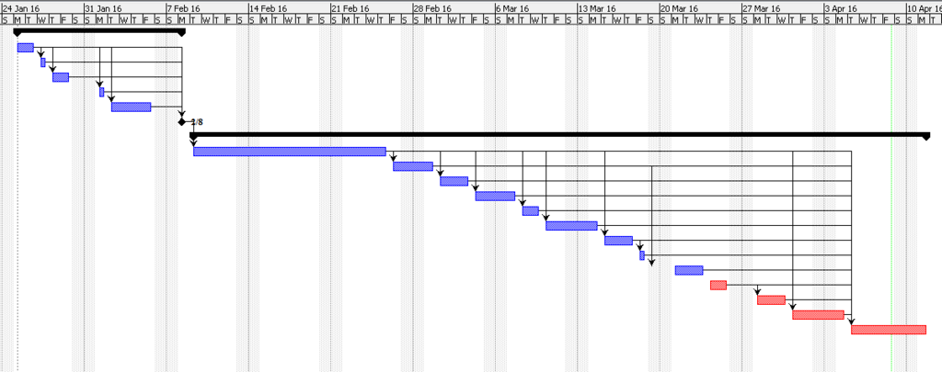

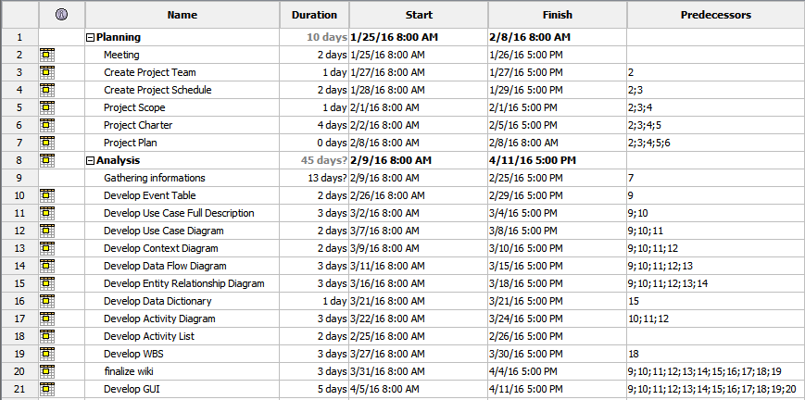

WBS

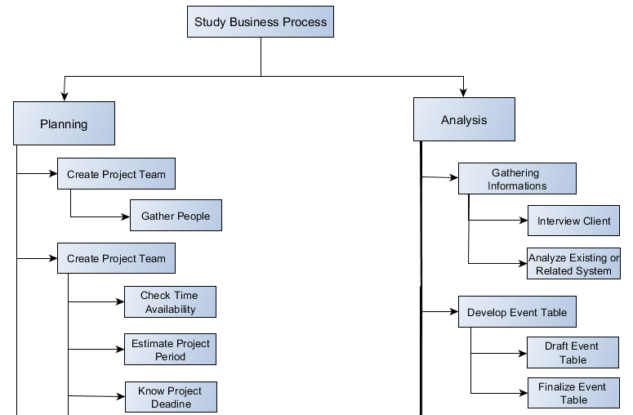

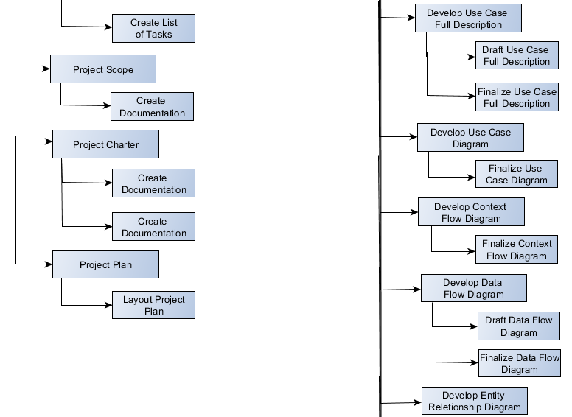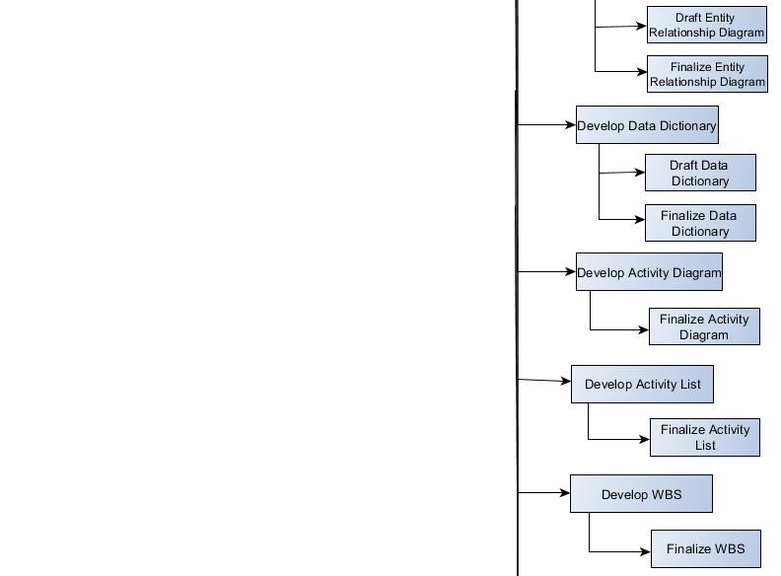

## 

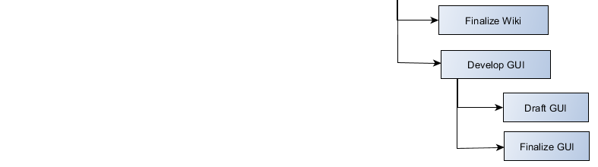

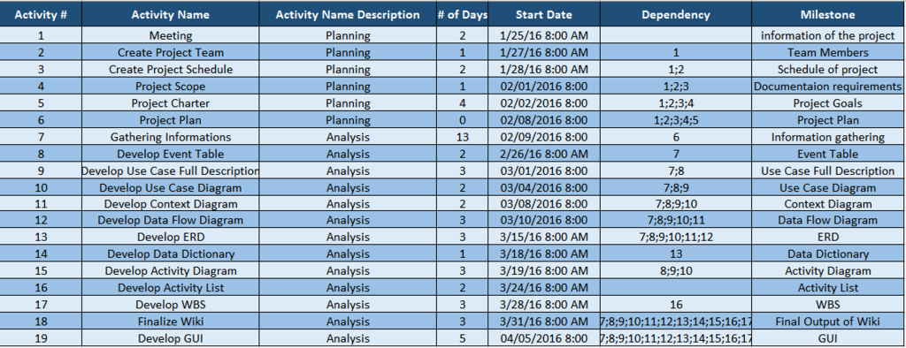Activity List

### 

### Screenshots of Proposed System

### 

### 